Rachel Gaines

Chris Herridge

Final Project Write Up

Overview

Our final project was to make a solar powered engine. We used a first order circuit to power and regulate our engine voltage. The engine requires 3VDC to run which our solar panel provides in daylight. Between 3V and 4.5V the engine runs periodically when the flashing LED blinks and shorts the circuit. With our 6V solar panel, the engine runs constant because so much current can get to the motor. We successfully wired our breadboard to engage the motor through the circuit.  
  
Parts List

(1) 2.2kΩ resistor

(2) 4700 μF capacitor  
(2) 2200 μF capacitor

1. 3906 transistor
2. 3904 transistor
3. Solar Panel

(1) Flashing LED

Schematic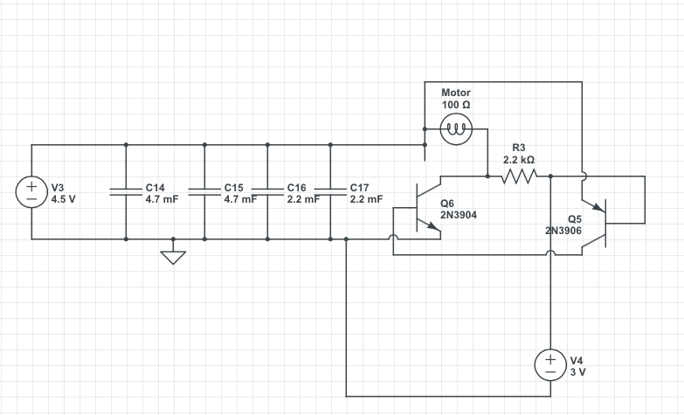

To simulate the motor we used a 100Ω light.  
To s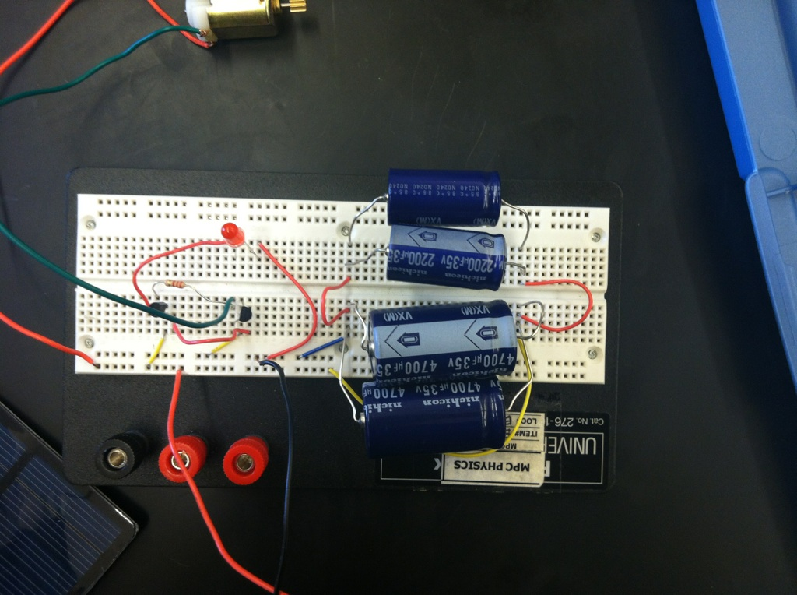imulate the FLED we used a 3V source

Pictures

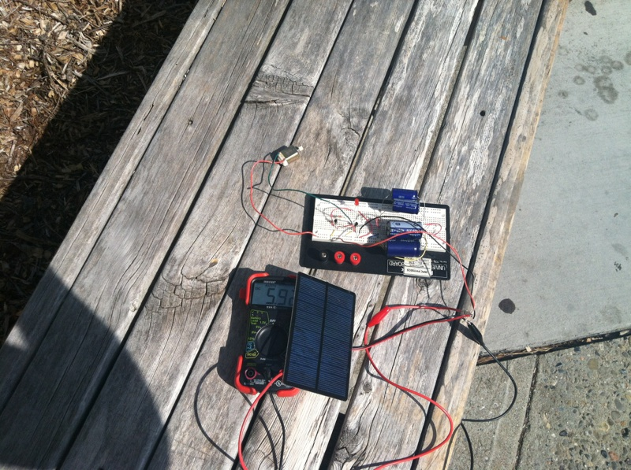

Conclusion  
 We started with circuit lab but the transistors and LED became problematic. We then proceeded to use the breadboard and ran into troubles with power distribution. While breadboarding, we shorted the motor and inadvertently blew 2 LEDs. We used parts off an old RC car, but ran into the problem of the motor being to large. It required over 2 Amps to start and a steady .7 Amps to run. This was too much for our 6V solar panel. We then acquired a smaller 3V DC motor and the circuit worked. It runs in daylight with the solar panel providing 6 V.