Lab 16 Names ______________

Final Project

In this lab you will construct a final electronics project, which could be based on your own interests, or chosen from the list of two options below:

1. Simple Persistence of Vision (POV) Demonstration

2. 4-Bit Digital-to-Analog Converter (DAC) Demonstration

**Option 1 POV Display**

A POV Display consists of a circuit that rapidly flashes a single row of LED lights while you wave it through the air. Because the LED flashes linger on our retina due to a phenomena called “Persistence of Vision,” you can use your retina like the paper for an old “dot matrix” display. Simply stare at a point while the flashing LED’s traverse your field of view and you should see a message in the lights!

For best results, lay the Arduino on TOP of the breadboard before wiring the connections. This will make it easier to wave the assembly around once you have it working.

You will be wiring pins 2-6 of the Arduino to drive the LEDs on your breadboard.

**Challenge:**

Instead of text, modify the program to display a simple 9x5 image, such as a smiley face, over and over again (you can hijack three letters from the alphabet provided in the demo code).

Visit the instructables page at <http://www.instructables.com/id/Simple-Arduino-POV-/>

If you have problems loading the sample code, try downloading it as a text file and just paste it into your browser. Use this link: <http://tomrebold.com/engr12lab/Labs/simplePOV.ino.txt>

Take a photo of your POV display in operation and paste it inside this file.

**Option 2 4-bit DAC**

In our lecture on Chapter 5, Op-Amps, we were given the design of a 4-bit DAC constructed from an inverting-summing op-amp with special resistor values:

According to the summing amplifier formula,



To avoid drawing too much current from a digital Arduino pin, the minimum value for R1-  
 R4 is 470 Ω. So we will choose the following resistors for R1-R4 in the circuit above:

R1 = 470 Ω, R2 = 1000 Ω, R3 = 2000 Ω, and R4 = 4000 Ω (use blue pots for R3/R4)  
 and the feedback resistor Rf = 220 Ω (use a second blue pot)

Since we don’t have 2000 Ω or 4000 Ω resistors, we will use our variable potentiometers set to 2000 Ω and 4000 Ω instead. Connect an ohmmeter between one outer pin and the center pin of the pot, then adjust the shaft until you get the desired resistance on your meter. Make sure you insert the pot so the correct pins are connected to your circuit.

Ideally all our resistors would be related by multiples of 2, so our DAC will have some small errors in output.

Build the circuit on the next page, and download the Arduino sketch at <http://tomrebold.com/engr12lab/Labs/simpleDAC.ino.txt>

Connect the Analog Discovery to the output of the op-amp. With the program running, you should see a repeating sawtooth waveform on the oscilloscope. You may notice the steps are not evenly spaced – that is because the resistors are not perfectly matched for this application.

If you see a lot of noise in your scope display, and you are using a laptop, disconnect the laptop from the power supply briefly so your computer can run on batteries. This eliminates the “ground loop” that forms between the two different grounding paths in the original circuit (the wall supplies and the computer supplies).

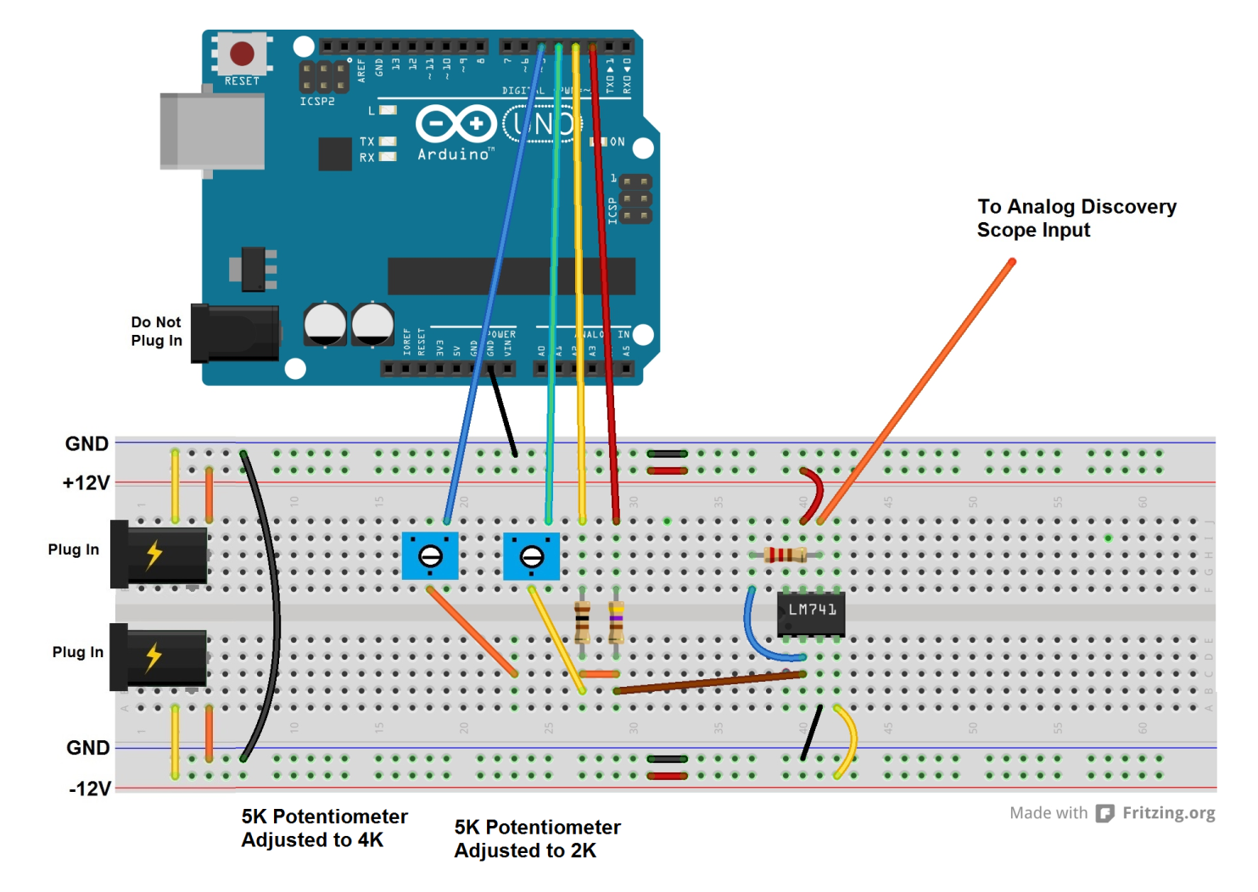

Take a photo of your circuit and copy it into this file

Take a screen shot of the oscilloscope output showing your sawtooth curve and copy into this file.