Datasheet for Lab 12: Phasor Nodal, Mesh, and Thevenin
Name(s): _______________________ Date: ________________________
Approximate Time To Complete (in hours)______________________
- Using ang.m and magPhs.m MATLAB / FreeMat

Point FreeMat’s current directory to the ENGR12L folder on your desktop (make one if needed). Download ang.m and magPhs.m into this folder. Test to make sure your install is correct with the command 10*ang(45) , you should get 7.07 + 7.07i. If you don’t, or get an error message, debug now.

Use MATLAB or FreeMat to compute the following (enter your final answers in the space provided)

- Express these quantities in rectangular form (use ang.m):

Quantity | MATLAB Command(s) you typed | Numeric Result
a = 4<30
b = 10<250
c = 5<300

- Display the values of rectangular a through c back in polar form (use magPhs.m):

Quantity | MATLAB Command(s) you typed | Numeric Result
a
b
c

- Using MATLAB to solve complex valued systems of equations
Solve the following system of equations in MATLAB, and express the answer in polar form:

(1+2j)*V1 + 3V2 + 2*V3 = 10<30
(1+j)V1 - j*V2 + 5*V3 = 0
(2 + j)*V1 - 10*V2 + j*V3 = 2<135

MATLAB commands and answers (make sure to express the answers in polar form)

- Nodal and Mesh Analysis
Problem 1 Solve for io(t) using a) Nodal and b) Mesh Analysis
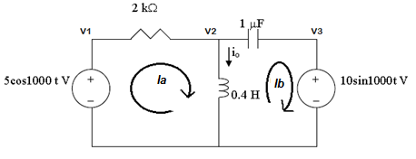

Nodal Analysis
A Matrix

B Matrix

All three V (V1, V2, V3) = (polar form)

Io = (polar) [should be 0.020 <-18.43 A]
[or 19.764<-18.3 mA]

io(t) =
Mesh Analysis
A Matrix

B Matrix

All two I (Ia, Ib) = (polar form)

Io = (polar)

io(t) =

Problem 2 Solve for Vo and Io using a) Nodal and b) Mesh Analysis
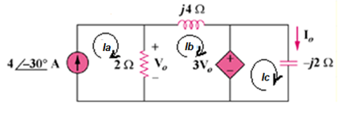

Nodal Analysis – only 1 equation and one unknown (Vo)
Vo = [should be 5.657<-75]

Io =

Mesh Analysis
A Matrix

B Matrix

All three (Ia, Ib,Ic) = (polar form)

Vo =

Io =

- Thevenin Equivalent – OPTIONAL for 10% Extra Credit
Problem 3 (OPTIONAL). Find the Thevenin equivalent for the following circuit.
- use Nodal Analysis to find Vth
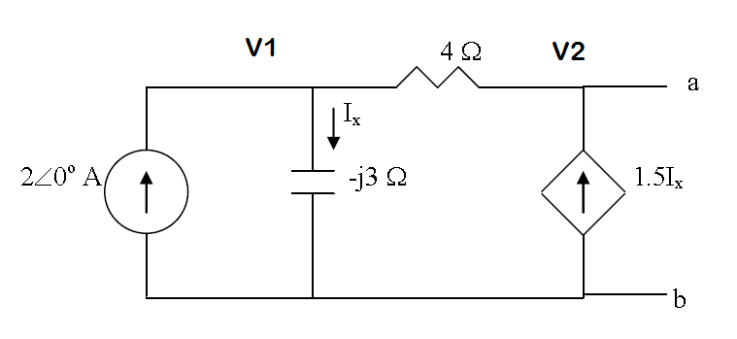

Nodal Analysis
A Matrix

B Matrix

All two V (V1, V2) = (polar form)

VTH = [should be -24 + 12i]

- Use Mesh Analysis to find In
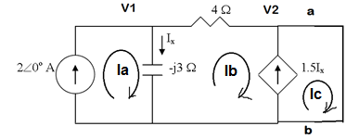

Mesh Analysis
A Matrix

B Matrix

All three (Ia, Ib,Ic) = (polar form)

In = [should be 2.64 + 0.48j]

- Use Vth/In to find Zth
Zth =

- Turn off independent source, connect a test voltage (or current source) equal to (typically) 1V. Use Mesh Analysis to find the current delivered by the test source (io). Find Zth by dividing 1V/io. Check against part c.

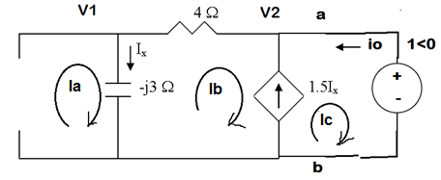

Mesh Analysis
A Matrix

B Matrix

All three (Ix, Ib,Ic) = (polar form)

Io =

Zth = 1<0/Io = [should be -8 + 6j]

When you are finished, please estimate the number of hours it took you to complete this lab and enter at the top of this datasheet.

