**Datasheet for Lab 11: Phasors and MATLAB**

Name(s): _______________________ Date: ________________________

Approximate Time To Complete (in hours)______________________

**Prelab:** Watch the [video overview and in-lab questions](https://youtu.be/kTbl0Z1zybo) for this lab

**Part 1: Complex Numbers and MATLAB / FreeMat**

Given that we have four complex numbers, some in rectangular form others in polar form:

a = 3 + 4i

b= -5 + 6i

c = 8<45 (This means a magnitude of 8 and an agle of 45 degrees)

d = 12<250

Use Matlab or FreeMat to compute the following (enter your final answers in the space provided)

1. Express these quantities in rectangular form:

|  |  |  |
| --- | --- | --- |
| Quantity | MATLAB Command(s) you typed | Numeric Result |
| a + b |  |  |
| a/b |  |  |
| c |  |  |
| c + d |  |  |

1. Express these quantities in polar form (magnitude and phase):

|  |  |  |
| --- | --- | --- |
| Quantity | MATLAB Command(s) you typed | Numeric Result |
| a |  |  |
| c/d |  |  |
| ab |  |  |
| a + c |  |  |

**Part 2: Phasor Transforms**

First verify the solution to (a) in both problems below, then use MATLAB or FreeMat to find answers to the other questions:

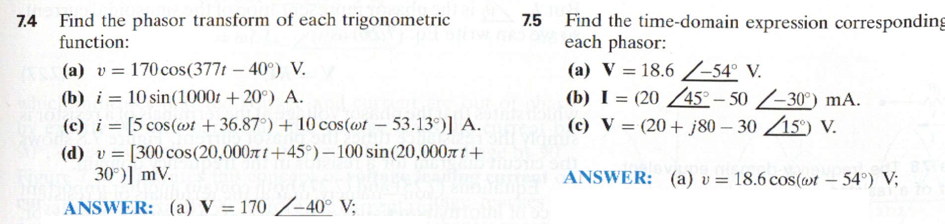

Answers

|  |  |
| --- | --- |
| 7.4 b) | 7.5 b) |
| 7.4 c) | 7.5 c) |
| * 1. d) |  |

Part 3. Basic Circuit Elements in the AC (Phasor) Domain

We sometimes refer to the impedance of a capacitor or inductor as Zc or ZL. Find Zc and ZL for the circuit shown. Assume the vin(t) is a 60 Hz sinewave, in which case the angular frequency  = 2f , which is ~377 radians/sec.



|  |  |  |
| --- | --- | --- |
| Quantity | MATLAB Command(s) you typed | Numeric Result |
| w |  |  |
| ZC |  |  |
| ZL |  |  |
| Phasor Transform of Vin |  |  |

# Part 4. AC Solution by Phasor Analysis (assume f still = 60 Hz)

Solve for phasor Vout in the example problem. Use values for Vin, ZL, and ZC that you calculated in Part 3.



|  |  |  |
| --- | --- | --- |
| Quantity | MATLAB Command(s) you typed | Numeric Result |
| Vout (phasor) |  |  |
| vout (time  domain) |  |  |

Exercises

2. Calculate v(t) by first translating the circuit into the phasor domain, solving for the answer, then converting back into the time domain.

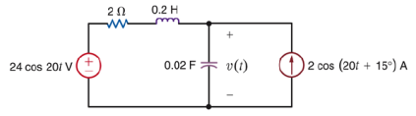

3. Calculate vx(t) by first translating the circuit into the phasor domain, solving for the answer, then converting back into the time domain.

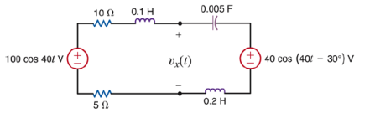

When you are finished, please estimate the number of hours it took you to complete this lab and enter at the top of this datasheet.