Datasheet for Lab 10: First-Order Time-Domain Simulation
Name(s): _______________________ Date: ________________________
Approximate Time To Complete (to 0.1 hours)______________________
Prelab –Watch the videos:
  - Lab 10 - Overview, CircuitLab, FreeMat, PSpice and
  - lab10 in lab q&a
    - Video Question Index
Exercises
Your datasheet should include ALL circuit diagrams from your circuit simulator, and ALL calculations clearly shown. In addition, you will need to capture plots of the transient curves from your circuit simulator and for the various exercises and include them in your datasheet.

- The switch in the circuit below has been opened for a long time and is closed at t = 0. Calculate and i₀(t) for t > 0 and confirm your results with a circuit simulator following the steps below.

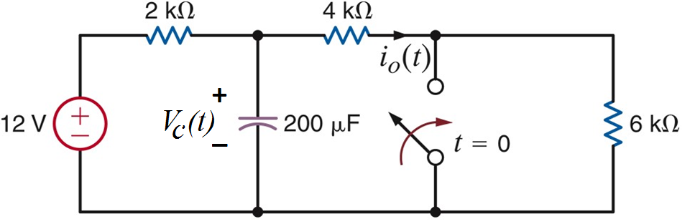
Procedure:
Although the problem requests i_{o}(t), we initially need to focus on Vc(t), the voltage of the capacitor, since that is the controlling variable for the transient response of an RC circuit. The following steps will help you arrive at a solution for Vc(t), which, you may recall, for a step response, will be of the form
Vc(t) = V∞ + (Vo - V∞)e^{-t/τ}
First, using your knowledge of circuit theory, find the
- Initial Voltage (Vo) across the capacitor:
- Final Voltage (V∞) across the capacitor:
- Equivalent resistance seen by capacitor when the switch is closed
- Time constant (τ) for the response:
- Use the above to construct your analytical solution for the equation for Vc(t)

- Develop an expression to calculate i_{o}(t) from Vc(t)

Now, verify your solution by comparing a plot of your solution for i_{o}(t) with a circuit simulatin result.

- Insert the FreeMat plot of i_{o}(t)

- Insert the circuit simulator schematic for this circuit

- Insert the circuit simulator plot of i_{o}(t)

- If there are any disagreements, go back and debug and/or communicate with the instructor for assistance.

- The switch in the circuit below has been closed for a long time and is opened at t = 0. Calculate i_{o}(t) for t > 0 and confirm your results with a circuit simulator following the steps below.
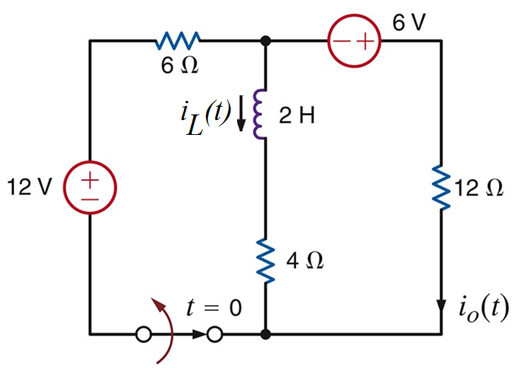
Procedure:
Although the problem requests i_{o}(t), we initially need to focus on I_{L}(t) (current through the inductor), since this is the controlling variable for the transient response. The following steps will help you arrive at a solution:
- Initial Current through the inductor:
- Final Current through the inductor:
- Equivalent resistance seen by inductor when the switch is open
- Time constant for the response:
- Use the above to construct the equation for IL(t):

- Expression to calculate io(t) from IL(t):

- Insert the FreeMat plot of i_{o}(t)

- Insert the CircuitLab schematic for this circuit

- Insert the CircuitLab plot of i_{o}(t)

- If there are any disagreements, go back and debug and/or communicate with the instructor for assistance.
Postlab Questions:
- Please explain the significance of the time constant tau in a first order circuit

- Why is it that io(t) changes instantly at t=0 for problem 2, but i_{L}(t) does not?
When you are finished, please estimate the number of hours it took you to complete this lab and enter at the top of this datasheet.

