Datasheet for Lab 6: Thévenin’s Theorem
Name(s): _______________________ Date: ________________________
Lab Kit: ______ Approximate time to complete (to 0.1 hours):___________________
Prelab
Watch the Lab 6 Overview In Class video at the video playlist for lab 6. You may also want to view Lab 6 In the Lab for video of students working through their questions on the lab.
Part 1 – Deriving the Thevenin Equivalent
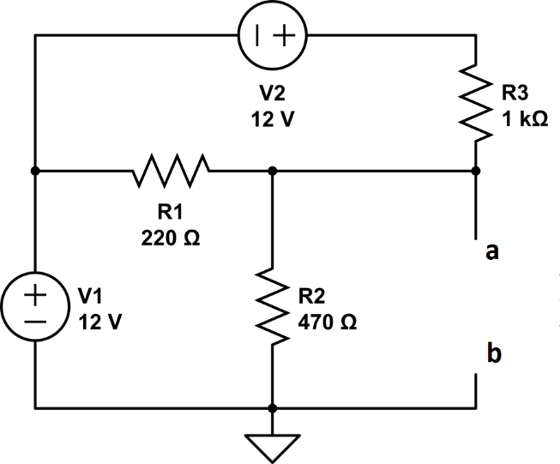

- Select the components necessary to build the circuit above. Measure the values of V1, V2 and R1 – R3 using your multimeter and record these values in Table 1.
Table 1 – Measured values of Resistors and Voltage Sources

Item | Nominal | Actual
R1 | 220 Ω
R2 | 470 Ω
R3 | 1000 Ω
V1 | 12 V
V2 | 12 V
- Using the component values you measured in step 1, derive the Thevenin equivalent circuit by finding the open circuit voltage (Vth) and the equivalent resistance (Rth) seen from the terminals a-b.
You may work the solution in the space provided on the lab handout, but when you finish, please summarize your work in the space below, including any equations you used to reach your final result.

To find Vth, you might consider which of the following methods would be the easiest to apply – Superposition, Source Transforms, or Nodal or Mesh analysis. You might also wish to derive Vth using two of the methods listed in order to confirm your results.

Summary of your derivation of Vth
(use the measured values of your components from Table 1 in your analysis)

Vth =
To find Rth, turn off the two voltage sources by replacing them with short circuits, and find the equivalent resistance between terminals a and b.
Summary of your derivation of Rth:
(use the measured values of your components from Table 1 in your analysis)

Rth =

Part 2 – Build the Circuit
- Now build the circuit on your breadboard. You may wish to refer to the Layout Tips section from the Lab 5 FAQ if you need guidance on how to layout your circuit in an orderly fashion.
- Apply power and measure the open circuit voltage at a-b, which should agree closely with the Vth you derived above. Record both of these in Table 2, along with an error calculation.

After everything is working, please insert two photos of your breadboard circuit here. One of them should include the voltmeter measuring Vab for example, and the other just a close up of the circuit itself.

- Now DISCONNECT the power supplies and replace them with a short circuit (jumper wire) connected across the nodes where they were previously connected on the breadboard. With NO POWER going to your circuit, measure the equivalent resistance between terminals a-b using your ohmmeter and record in Table 2, along with an error calculation.

Table 2 – Calculated and Measured values of Vth and Rth

Item | Calculated ^{Step 2} | Measured | % Error
Vth
Rth |  | ^{(see step 5)}
- If your % Error calculation is more than 3% for Vth and Rth, spend some time investigating whether you made an error, either in your analysis or your breadboard wiring. Is your 470 Ω resistor really 4.7 kΩ? Did you make a mistake in assessing the series / parallel resistors for Rth?
SHOW YOUR RESEARCH into the source of errors, if either Vth or Rth is off by more than 3%.
You may wish to build a circuit simulation as another way of resolving disagreement between your model and your breadboard. Include screenshots of worked problems, of breadboards, of simulations. Note – you don’t have to do this step if your measurements are within 3% of your predictions.
Conclusion of your error analysis, (if any)
Part 3 – Find RL for Max Power
Now that we have a Thevenin equivalent model of our circuit, we can verify the accuracy of this model for predicting the load voltage when different resistors are connected to terminals a-b. We can also assess whether the predicted value of R_{L} to achieve maximum power seems correct.
After all, the Thevenin model of our circuit is so simple, we can use the voltage divider formula to determine the load voltage when we attach various load resistors to the circuit.
- Select the resistors called for in Table 3 (all but the last 2), then measure and record these in the Table.
- Then use your Thevenin circuit with the voltage divider formula to predict the voltage VL for each load resistor when it is inserted into your breadboard between the a-b terminals.
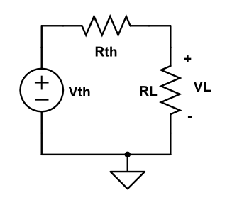
Thevenin Model of the original circuit, with load RL attached.

- Remove the jumper wires you added in step 5 and re-connect the voltage sources to the breadboard. Now insert the different load resistors into your breadboard circuit between the a-b terminals and measure VL for each using your voltmeter, recording the values in Table 3. Also compute the % error between Calculated VL and measured VL.
- For each load resistor RL inserted into the breadboard, also calculate PL, the power absorbed by the resistor, using PL = (VL)²/RL with the measured values.
- According to the maximum power transfer rule, the load resistance that will absorb the most power from the circuit is the same as the Thevenin resistance. You can construct a load resistor “network” that is equivalent to Rth by assembling the same resistor values used in your circuit, in a manner that provides the same net resistance. For instance, if Rth is the parallel combination of R1, R2, and R3, you can select three new resistors with these values and insert them in parallel across terminals a-b. Do this now and measure VL when your load resistor RL is the same as Rth.
- Finally, complete the table by forming an RL across a-b from two 100 Ω resistors in parallel (50 Ω).

Table 3 – Predicted and Measured values of VL and PL
for different load resistors RL

Selected RL | Measured RL | Calculated VL ^{Voltage Divider Eq} | Measured VL  ^{on breadboard} | % Err | Calc PL
1 kΩ
470 Ω
220 Ω
100 Ω
Rth ^{see step 11}
50 Ω ^{see step 12}
Part 4 – Postlab Questions
- Looking back on your results, how effective was the Thevenin model of your circuit at predicting the behavior of different loads attached to the actual circuit on your breadboard?

- Discuss whether the power absorbed by the load seemed to peak at the expected value of Rth or not.

- How would you describe the principle value of Thevenin’s theorem applied to circuit analysis?

When you are finished, please estimate the time it took to complete this lab to 0.1 hours and enter this in the space provided at the top of the datasheet.

