ENGR 12 Assignment 9 Due: next wed
Part I. Drills -- 1 point each
Determine the type of response (under, critical, over-damped) for these 2nd order circuits:
- 2)
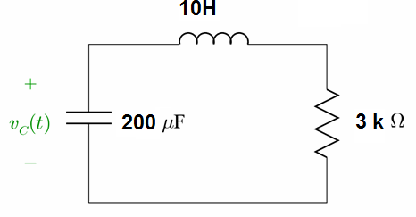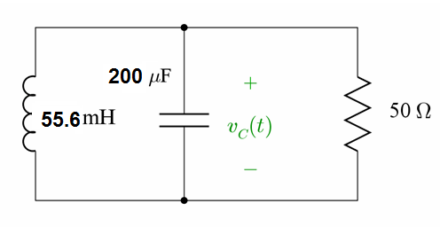
3) For the following circuit, the switch is initially closed and has been for a long time.
Find the initial values of Vc(t), iL(t), VL(t) and Vr(t) at t=0-, and diL(t)/dt at t=0+.
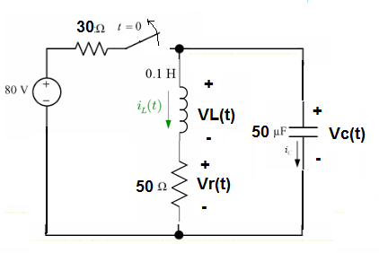
4) Derive the formula for the inductor current iL(t) in problem 3 for t>0.
5) [Skip this!] Derive the formula for the capacitor voltage Vc(t) in problem 3 for t>0.
6) What value of the inductor in problem 3 would make the circuit critically damped?

Part II. Assisted Problem Solving – 2 pts
7) The natural voltage response of a parallel RLC circuit is v(t) = 75e^{-8000t}(cos 6000t – 4sin 6000t) Volts, for t>0  If the inductor is 400 mH, find the values of C, R, Vo | PLAN  - note that this is underdamped  - compare the equation to the formula for underdamped and notice where different parameters appear and match them up using algebra where needed.
Part III. Unassisted Problem Solving – 3 points
8)