ENGR 12 Assignment 5 Due: next wed

**Part I. Drills -- 1 point each**

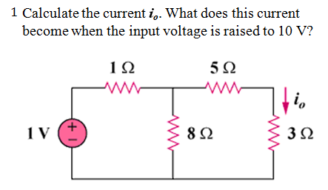 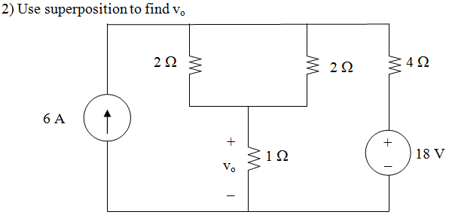

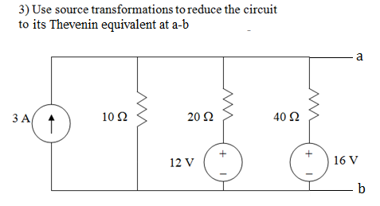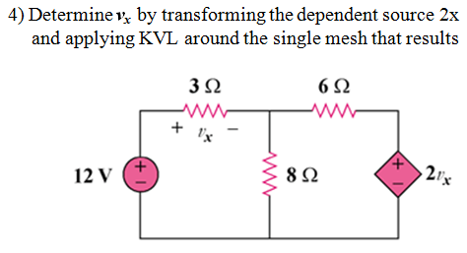

1. Find just the "Lookback Resistance" (Rth) at a-b by turning off the independent sources  
   a) 5b)

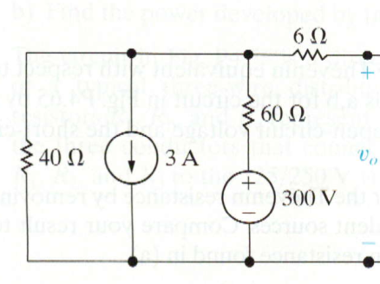 

**Part II. Assisted Problem Solving – 2 pts each**

|  |  |
| --- | --- |
|  | PLAN   1. Find Rth by turning off sources 2. Find In by finding the short circuit current through a-b |
|  | PLAN   1. Find the Thevenin equivalent at a-b    1. Vx is Vth so just use nodal analysis to find Vth    2. To find Rth Apply a 1A source at a-b and find the voltage Vo it provides,    3. use Rth= Vo/ 1A 2. Use Pmax = Vth2/(4Rth) |

**Part III. Unassisted Problem Solving – 3 points each**

