ENGR 12 Assignment 12 Due: next wed

**Part I. Drills -- 1 point each**1) If *v*(*t*) = 160 cos 50*t* V and *i*(*t*) = - 20 sin (50t - 30°) A, calculate the instantaneous power and the average power.

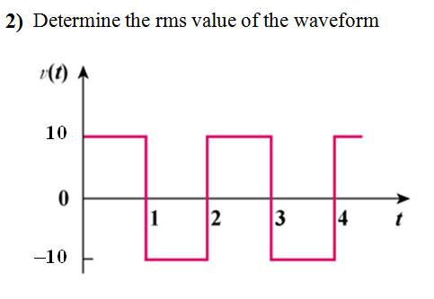

3) For the following voltage and current phasors, calculate the complex power, apparent power, real power, and reactive power. Specify whether the pf is leading or lagging.

(a) **V** = 220 ∠30° V rms, **I** = 0.5 ∠60° A rms

(b) **V** = 250 ∠-10° V rms, **I** = 6.2 ∠-25°A rms

(c) **V** = 120 ∠0° V rms, **I** = 2.4 ∠-15° A rms

(d) **V** = 160 ∠45° V rms, **I** = 8.5 ∠90° A rms

4) An electrical load operates at 120 Vrms. The load absorbs an average power of 3 kW at a leading power factor of 0.5. Use the power triangle to calculate a) the power factor angle, b) the apparent power, |S|, c) the reactive power |Q| of the load. d) the impedance of the load (use **S** = **Vrms** **Irms\***, or **Irms** = **(S/Vrms)\***, then find Z=**Vrms/Irms**)

**Part II. Assisted Problem Solving – 2 pts**

|  |  |
| --- | --- |
|  | Note the 120<0 voltage is in magnitude not rms   1. Find the thevenin equivalent.   Vth also in magnitude not rms   1. Then ZL = Zth* 2. Use the max power transfer formula   Pmax = |Vth|2/(8*Rth)  Where Rth is the real part of ZL or Zth  (If voltages were in rms, Pmax=|Vthrms|2/(4*Rth)) |
|  | 1. Ignore capacitor C (it’s not attached) until step c 2. Find Irms and use that to find S 3. Draw the power triangle 4. Use the power factor correction formula for the capacitor to balance a load. |

**Part III. Unassisted Problem Solving – 3 points**

