ENGR 12 Assignment 10 Due: next wed

**Part I. Drills -- 1 point each**For questions 1 and 2, assume a = 3 – 4j, b = –6j, c = 8<-45 o, d = 15<250o

|  |  |
| --- | --- |
| 1. Express the following in Rectangular form:    1. (a + b)    2. ( a / b)    3. c    4. c* (complex conjugate of c)    5. (c + d) | 1. Express the following in Polar form:    1. b    2. b* (that's the complex conjugate of b)    3. c/d    4. a b    5. a + d |

1. Complete the missing cells of the table defining three sinusoids and express each as $i\left(t\right)= Im cos⁡(ωt+ φ)$  
      
     
   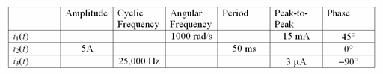
2. Use the concept of a phasor to convert the following expressions into a simpler form:
   1. 100cos(500t – 43 o) + 45cos(500t + 120 o)
   2. 200cos(377t + 75 o) + 50sin(377t – 100 o)
   3. 5cos(wt) + 5cos(wt+120 o) + 5cos(wt-120 o)

1. Find the complex impedance AND admittance of the following at a-b, given w = 5000 Radians/sec, express in both polar and rectangular form:  
   a) b)

 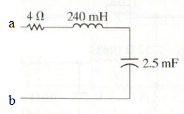

**Part II. Assisted Problem Solving – 2 pts**

|  |  |
| --- | --- |
| 1. Find the the current through the 25nF cap in 5a) when a current source of 10cos(5000t + 120o) is applied at a-b.   Express your answer in both phasor and time-domain form | Plan   1. Convert the source current into phasor form 2. Use the current divider formula to find phasor Ic 3. Convert phasor Ic to time domain |
| 1. Find the voltage across the 2.5mF cap in 5b) when a voltage source of 50cos(5000t – 90 o) is applied at a-b.   Express your answer in both phasor and time-domain form | PLAN   1. Convert the source voltage into phasor form 2. Use the voltage divider formula to find phasor Vc 3. Convert phasor Vc to time domain |

**Part III. Unassisted Problem Solving – 3 points**

8) What value of w will the impedance at a-b in problem 5b become purely resistive?