ENGR 12 Assignment 1 Due: next wed

**Part I. Drills -- 1 point each**

1.1 How many coulombs are represented by these amounts of electrons:

(a)  (b) 

(c)  (d) 

2) if the current flowing into a device i = 200 Amps, how many positive charges have entered the device after 1 millisecond?

3) A solar panel puts out power based on the height of the sun and can be modelled by the equation

P = 20t – 1.667 t2 Watts, where t is time in hours from 0 to 12 (representing 8am to 8pm)

Power output vs time for 1 solar panel

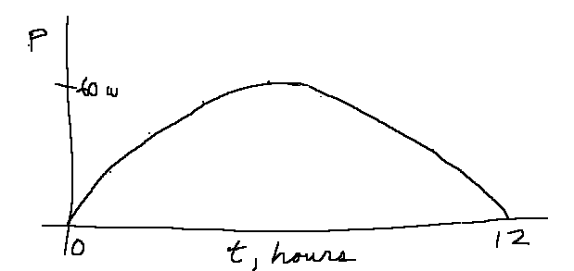

If a roof has 10 solar panels installed, how many kilowatt-hours of energy would be produced each day?

4) For each of the following Ideal Basic Circuit Elements, determine if it follows the Passive Sign Convention, and then determine how much power is being absorbed or delivered by the element.

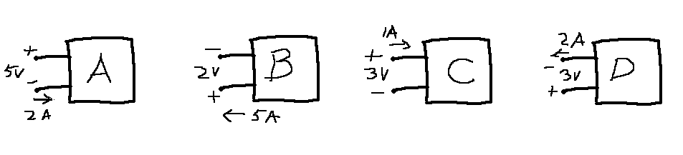

Passive Sign Convention? ________ ________ _________ _________

Calculated Power ________ ________ _________ _________

Absorbed or Delivered? ________ ________ _________ _________

**Part II. Assisted Problem Solving – 2 pts each**

|  |  |  |  |
| --- | --- | --- | --- |
| 1.15   |  |  | | --- | --- | | The current entering the positive terminal of a  device is  and the voltage across the device is .   1. Find the charge delivered to the device between *t* = 0 and *t* = 2 s. 2. Calculate the power absorbed. 3. Determine the energy absorbed in 3 s. |  | | PLAN   1. integrate i from t=0 to 2 2. compute v(t), then multiply by i(t) 3. integrate p(t) from t=0 to 3 |
| 1.17) The figure shows a circuit with five elements. If    calculate the power *p*3 received or delivered by element 3. | PLAN   1. The total sum of power should be zero |

**Part III. Unassisted Problem Solving – 3 points each**

7) One way of checking your circuit solutions is to take your solved circuit variables and verify that the total power delivered = the total power absorbed (conservation of energy principle). For the following circuit, make a table entry for each circuit element and calculate the power associated with it (and whether absorbing or generating power). When you have finished, a) find the total power delivered by the circuit elements that are delivering power, b) the total power dissipated by those elements absorbing power (and verify they are equal).

