ENGR 12 PRACTICE TEST 1 SOLUTIONS
These are representative problems. The actual test will be shorter, but you should expect a number of short drill type questions with 1 or two extended problems similar to the material covered in these examples.
- The power associated with the 8A Current Source is

  - 256 W, producing
  - 704 W, absorbing
  - 576 W, producing
  - 384 W, absorbing

- For the following circuit, the voltage drop across the 12 Ohm Resistor in Volts is:
  - 2.57142 b. 4.66666 c. 5.45454 d. 5.76

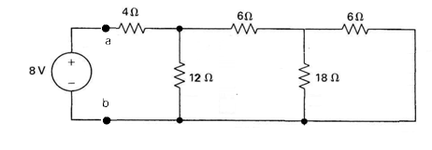

- For the following circuit, it has been determined that ia = 1 Amp and ib = 0.5 Amps. Using KVL, OL and KCL, find vc, ic and then id. Ignore all other components except those that are labeled.
The value of id in Amps is

- 0.06
- 0.3
- — 0.1
- 0.22

Vc = 10V
Ic = .4A
Id = -0.1A

- If the interconnections of ideal sources are valid,  - Identify which sources are developing and which sources are releasing power  - Verify that the total power developed in the circuit equals the total power absorbed  60V: P=480 Absorbing  20V: P=160 Producing  8A: P = 320 Producing | 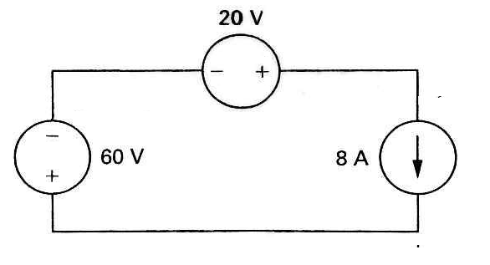
- For the following circuit
  - Find Rab for the resistive network shown (HINT: it’s a whole number, no decimal)
  - Find the total power delivered by the voltage source
  - Find the voltage drop across the 20 Ohm Resistor

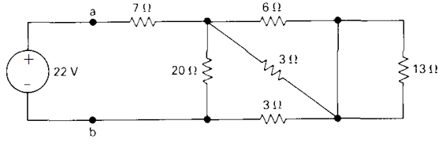
TRICK! 13 || 0 (short) = 0, so remove 13 Ohm resistor
a) Rab = 7 + 20||( 6||3 + 3) = 7 + 20||5 = 11
b) Itotal = 22/11 = 2A, P = 2*22 = 44W
c) Reff = 20||5 = 4 Ohms, so V20 = 4*22/(11) = 8V

- For the following circuit, it has been determined that ia = .5 Amps. Using KCL, KVL and OL,

  - Find vb = 16
  - Find ib = 0.5
  - Find ic = 1
  - Find vd = 28
  - Find ie = 3
  - The power delivered by the 40V source = 120W

Hint: Answers to d, e, and f should be whole numbers

