ENGR 12 Assignment 7 Due: next wed
Part I. Drills -- 1 point each
- An inductance of 2 mH has a current i = 5.0(1 – e^{-5000t}) A, for t>0. Find the corresponding voltage as a function of time, v(t) = ...

- A voltage pulse v = 50 sin(200t) V, for 0 < t < 0.005pi sec (this is one half cycle of a sinewave) is applied to a 20uF capacitor. Find the corresponding current as a function of time, i(t) = ...

- A current pulse i = 50 sin(200t) A, for 0 < t < 0.005pi sec (this is one half cycle of a sinewave) is applied to a 20uF capacitor, which has an initial voltage of 0V. Find the corresponding voltage as a function of time, v(t) = ...

- Find the equivalent inductance of the 3 parallel connected inductors:
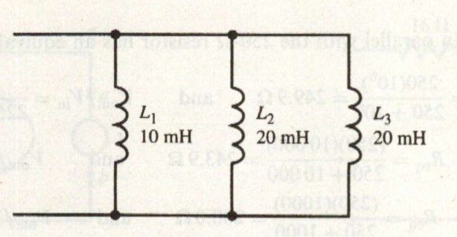
- 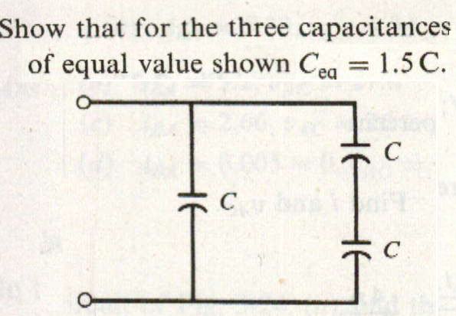

Part II. Assisted Problem Solving – 2 pts each
6 For problem 2,  - find the corresponding power over the same interval (0 to 0.005pi sec)  - find the energy in the capacitor over the same interval. (0 to 0.005pi sec)  - What is the maximum energy stored?  careful with UNITS!!  - plot all 4 curves using matlab or www.wolframalpha.com , copy plots into a 1 page Word file (align them vertically, add labels) and print/staple to your homework | PLAN  - To plot in Wolfram, use an expression like so:  plot[x^2, {x, 0, 10}]  (plots the function x^2 vs x from 0 to 10)  - For integration, use dummy variable substitution  4+Integrate[x^2, {x, 0, t}] (integrate wrt x from 0 – t, with initial value 4 )  - To capture a plot from Wolfram, hover over lower left corner to activate copy, then go back and R-click the plot, choose Copy then paste into Word.  - More details in ppt lecture
7 For problem 3,  - find the corresponding power over the same interval (0 to 0.005pi sec)  - find the energy in the capacitor over the same interval. (0 to 0.005pi sec)  - What is the maximum energy stored?  careful with UNITS!!  - plot all 4 curves using matlab or wolfram alpha, copy plots into a 1 page Word file (align them vertically, add labels) and print/staple to your homework | PLAN  same as above
Part III. Unassisted Problem Solving – 3 points each
8)
