ENGR 12 Assignment 2 Due: next wed
Part I. Drills -- 1 point each
  - Use Ohm’s Law: 2.10) Find i1 and i2 using KCL
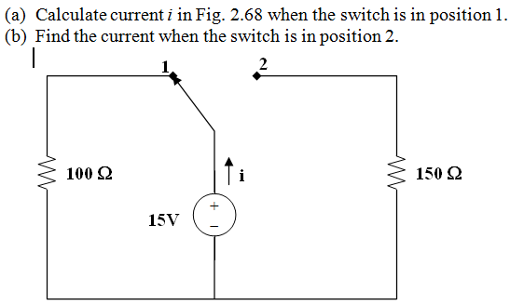 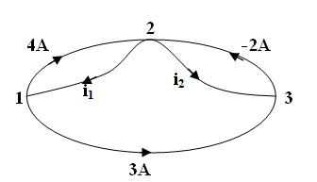

  - Find v1 and v2 using KVL 2.15 Find i1 thru i4
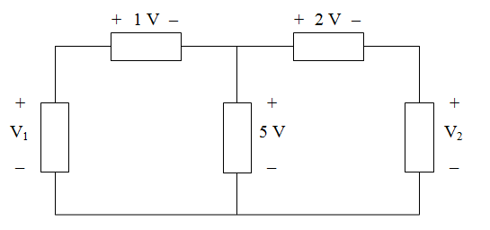 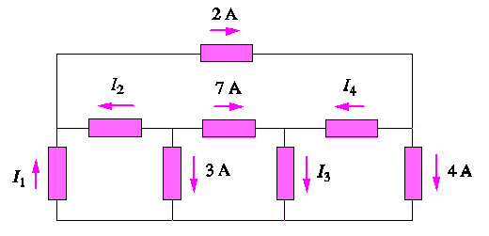

2.20 Determine i0 2.22 Find Vo in the Circuit
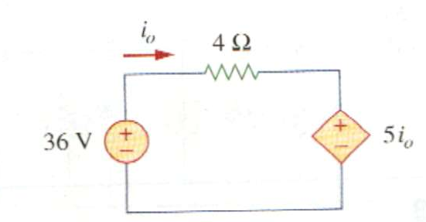

Part II. Assisted Problem Solving – 2 pts each
7 Find the value of R2 in the circuit below  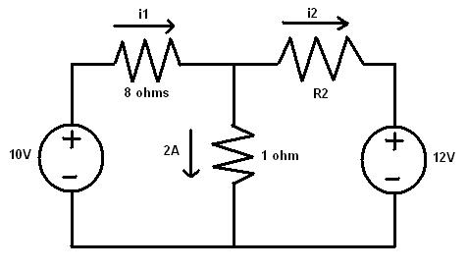 | PLAN  - Use OL to find the voltage across the 1 ohm resistor  - Now use KVL around the left loop to find V1, the voltage across the 8 ohm resistor.  - Use this voltage to determine the value of i1  - Use KVL around the right loop to find V2, the voltage across the R2 resistor  - Use KCL at the top center node to determine the value of i2.  - Knowing i2 and V2, use OL to find the value of R2.
2.15 Calculate v and ix in the circuit | PLAN  - v can be found readily using KVL  - also use KVL to find the voltage of the dependent source.  - Solve for ix
Part III. Unassisted Problem Solving – 3 points
8) Find the current io in the circuit below
