ENGR 12 Assignment 14 Due: next wed
Part I. Drills -- 1 point each
1) A series RC lowpass filter requires a cutoff frequency of 8 kHz. Use R = 10 kΩ and compute the value of C required.
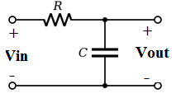

2) A series RL highpass filter with a cutoff frequency of 2 kHz is needed. Using R = 5 kΩ, compute
a) L, b) |H(w)| at 200 Hz, c) Phase(H(w)) at 200 Hz
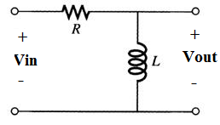

3) A series RLC has a 0.1 uF capacitor. Find R and L for a bandpass filter with a center frequency of 12 kHz and a Q of 6
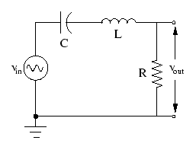

4)
Part II. Assisted Problem Solving – 2 pts
6) Find the transfer function Vout/Vin and the corner frequency w. What kind of filter is it? Plot the magnitude and phase of H(w) using Freemat or WolframAlpha.  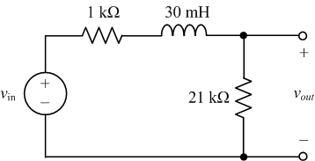 | Plan  - It tends to be easier to derive transfer functions when the component values are defined as symbols: use R1, L and R2 for the three values.  - Use the voltage divider formula to derive H(w)  - Then find H(w) by taking Vout/Vin  - Substitute in the numeric component values, and  - Plot the magnitude and phase of H(w) using Freemat.
7) Find the transfer function Vo/Vs for the following circuit. Show that it is a low pass filter.  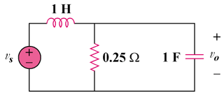 | PLAN  - Use L, R, and C as the component values while you derive H(w)  - Simplify the formula into a simple fraction form. (remove fractions in the numerator and denominator)  - Determine H(0) and H(infinity) and use this to argue that kind of filter it is
Part III. Unassisted Problem Solving – 3 points
8) Find the transfer function for this circuit given R1=R2=110 k, C1 = 4uF, C2 = 2 uF. Determine the cutoff frequency and plot the magnitude in Freemat. Hint: Use Nodal Analysis at the R1/R2/C1 node and Node 3. Negative feedback means V2 = V3.
