ENGR 12 Assignment 11 Due: next wed

**Part I. Drills -- 1 point each**

1. Use Freemat to solve the following system of equations for I1 and I2 (answer in rectangular form):

(27 + 16j ) I1 — (26 + 13j) I2 = 0

(13 – 14j) I1 — (12 – 16j) I2 = 150

1. Find the Thevenin Eq for this Norton and the Norton for this Thevenin



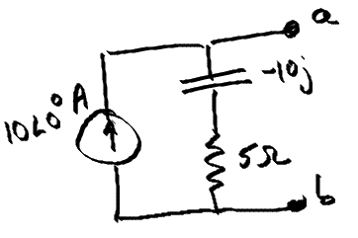 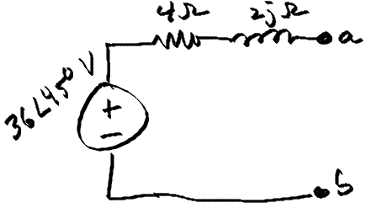

1. **Find v1(t) using Nodal Analysis 4) Use Mesh Analysis to find i(t)**

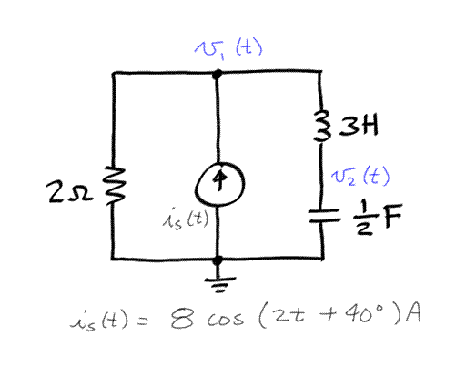 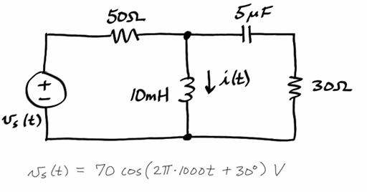

1. **Find the Thevenin Equivalent at a-b:**

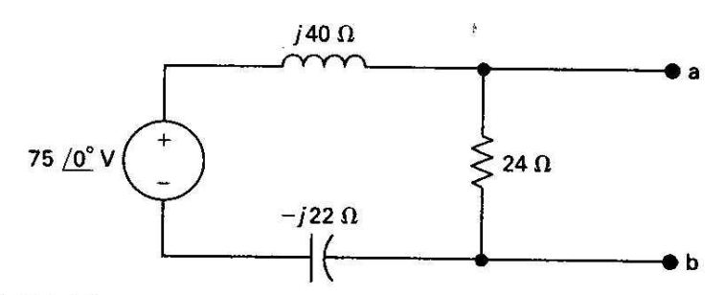

**Part II. Assisted Problem Solving – 2 pts**

|  |  |
| --- | --- |
| 6) Find Vx in phasor form using the mesh current method | Plan   1. Note the arbitrary direction of the mesh currents, be careful when deriving mesh equations. 2. Using I3 as shown, Vx = 10(I3) 3. Use matlab/freemat to solve the set of equations 4. Check your answer by verifying KVL around the perimeter of the circuit |
| 7) Use Node Voltage to find I in the circuit below | PLAN   1. Use ref. as the ground node 2. Use freemat/matlab to solve equations 3. Check your answer by verifying KCL at node 1 |

**Part III. Unassisted Problem Solving – 3 points**

8) Find the Thevenin equivalent of the circuit at a-b.

