ENGR 12 TEST 3 100 Points NAME: ________________
- (10 pts) A 0.1H inductor is driven by the a current pulse i(t) = 4t-t² Amps over the time interval 0<=t<=4 seconds. The current is 0 outside of this time period.

  - Find the voltage over this same time period:
.1( 4 – 2t) V

  - What is the energy in the inductor at 0 sec:____0____________________________
2 sec______________0.8J____________________

- (20 pts) Find the steady state solution for io(t) if vg(t) = 40cos(500t) Volts
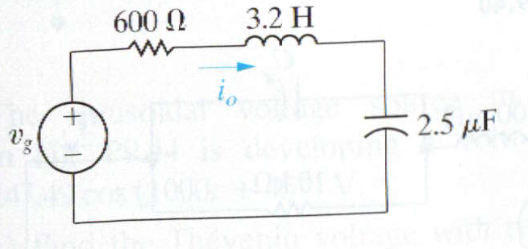
W = 500
ZL = j 3.2*500= 1600j
ZC = -j/(500*2.5x10^-6) = -800 j

Ztotal = 600 + j(1600-800) = 600 + 800 j

Vg = 40<0
Io = Vg/Ztotal = 40 / (600 +800j) = .024 - .032i = .04 < -53.13

Io(t) = 40 cos (500t -53.13 ) mA

- (30 pts) The switch has been open in the following circuit for a long time before closing at t=0.
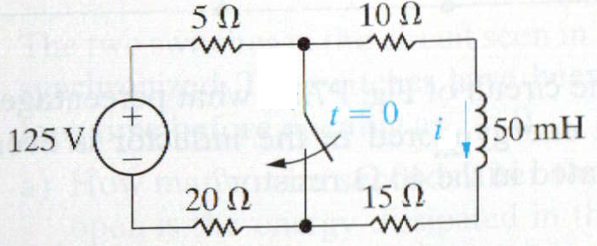
Find
- this is a (circle one) natural/step response

- the initial current i in the inductor at t=0- __125/50 = 2.5A___
- the final current i in the inductor at t = infinity __0A___
- the effective resistance seen by the inductor for t>0 __25 Ohm_________________
- time constant tau for t>0 ______L/R .05/25 = .002s
- the expression for i(t) for t>0 ______2.5 e ^{–t/.002}_=__2.5 e ^{–500t}

- (40 pts) The switch has been closed a long time before opening at t=0
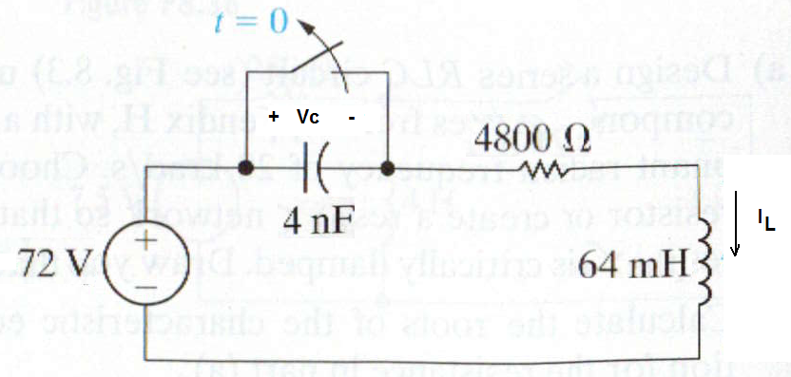
- this is a (circle one of each pair) series/parallel step/natural response
- Find IL(0-) ______72/4800 = 15mA_______
- Find Vc(0-) _____0____
- Find IL(∞) _____0_____
- Find Vc(∞) _____72______
- Find α ___R/2L = 37500______
- Find wo __1/sqrt(LC) = 62500________
- Critically Damped, Underdamped or Overdamped ? _________UNDER_________________
- Find dVc/dt(0+) ___________________________
dVc(0+)/dt = ic(0+)/C = IL(0+)/C = IL(0-)/C = .015A / 4x10^-9 = 3,750,000 V/s
Vc(0+) = 0

- Find the complete solution for v(t) for t>0

Wd = sqrt(wo^2 – a^2) = 50000
V(0+) = 72 + B1
dVc/dt(0+) = - a B1 + wd B2
B1 = -72
3.75x10^6 = -37500B1 + 50000B2 , B2 = 21
V(t) = + 72 + e^{-37500t} (- 72cos(50000t) + 21 sin(50000t))

