ENGR 12 TEST 3 100 Points NAME: ________________
- (10 pts) A 0.1H inductor is driven by the a current pulse i(t) = 4t-t² Amps over the time interval 0<=t<=4 seconds. The current is 0 outside of this time period.

  - Find the voltage over this same time period:

  - What is the energy in the inductor at 0 sec:________________________________
2 sec__________________________________

- (20 pts) Find the steady state solution for io(t) if vg(t) = 40cos(500t) Volts
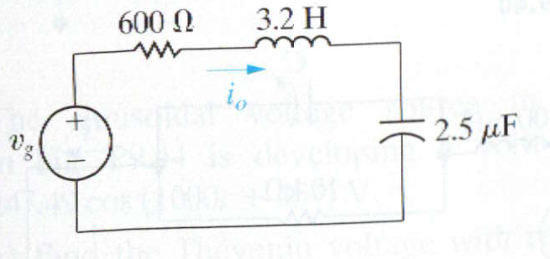

- (30 pts) The switch has been open in the following circuit for a long time before closing at t=0.
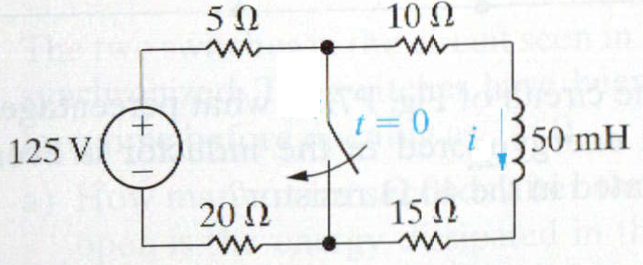
Find
- this is a (circle one) natural/step response

- the initial current i in the inductor at t=0- ______________
- the final current i in the inductor at t = infinity ______________
- the effective resistance seen by the inductor for t>0 ___________________
- time constant tau for t>0 _____________________________
- the expression for i(t) for t>0 _________________________

- (40 pts) The switch has been closed a long time before opening at t=0
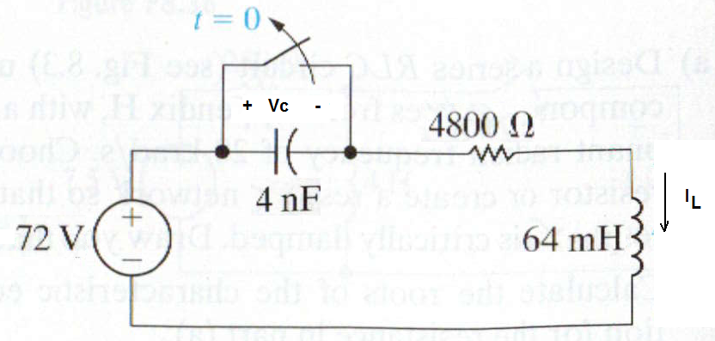
- this is a (circle one of each pair) series/parallel step/natural response
- Find IL(0-) ______________________
- Find Vc(0-) _____________________
- Find IL(∞) ______________________
- Find Vc(∞) ______________________
- Find α ________________________
- Find wo ________________________
- Critically Damped, Underdamped or Overdamped ? ______________________________
- Find dVc/dt(0+) ___________________________
- Find the complete solution for v(t) for t>0

